June 6th 2018

Trying to figure out why it is not deforming symmetrically, initial guess is because

Quiver(zeros(size(gy)),gy) in cfd code gives

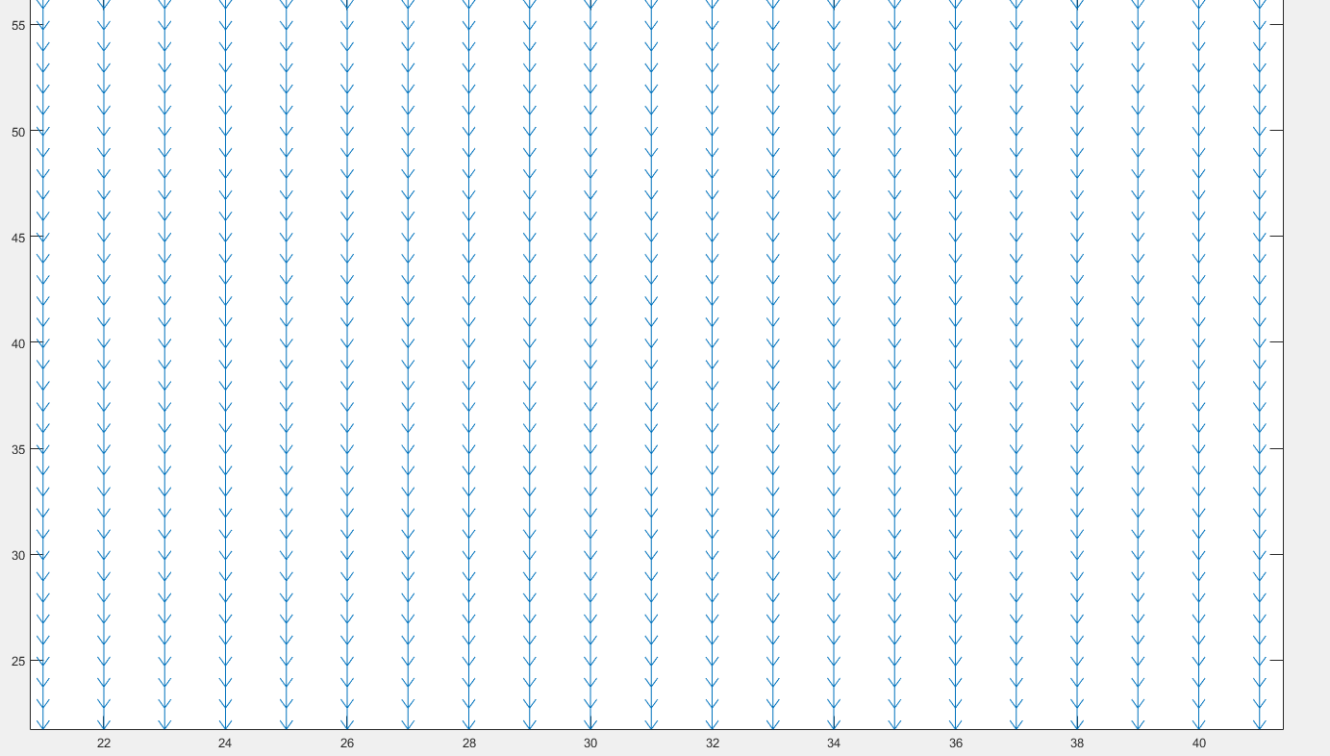

And quiver (zeros(size(fy_avg)) from FDTD gives

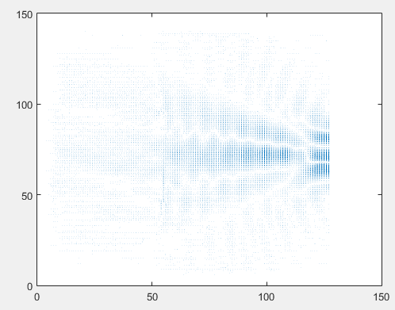

Something is transposed or flipped